1.This is the INDEX page for my Project

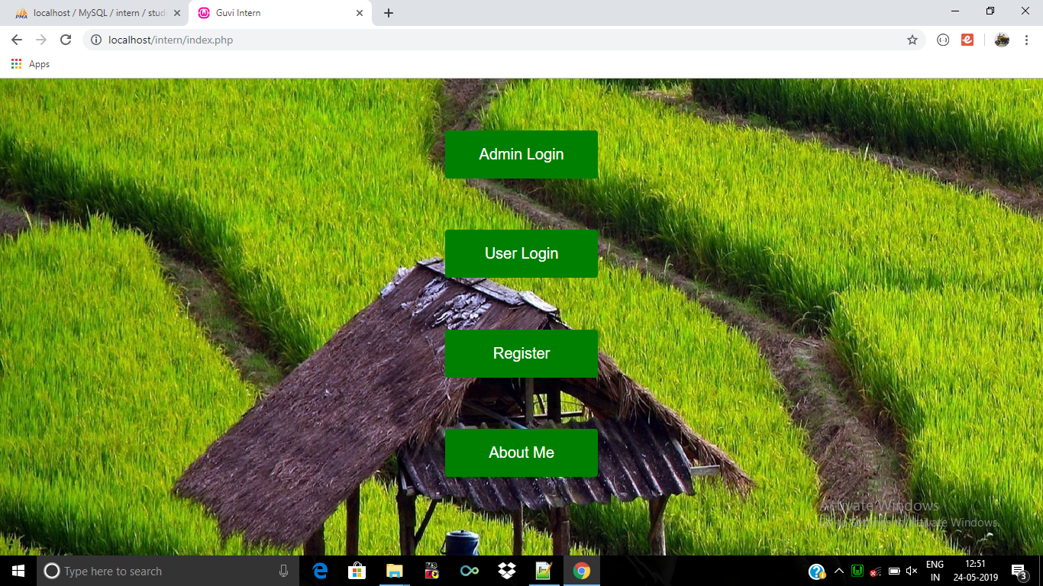

2.Admin Login Page:

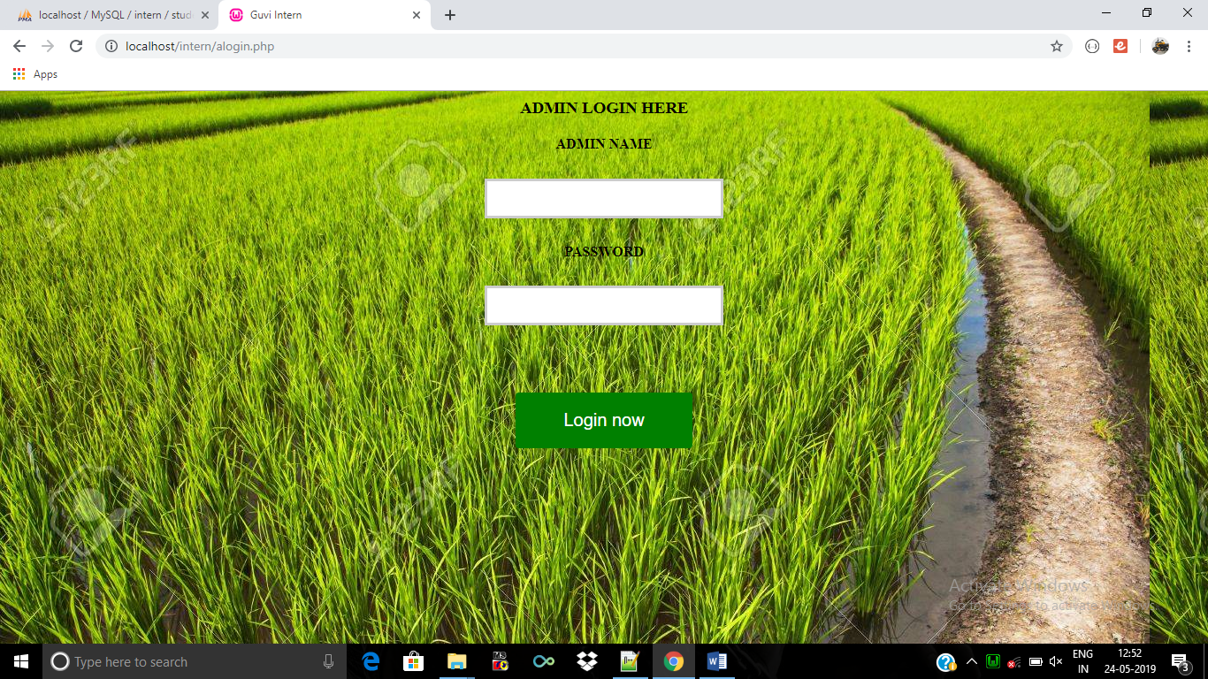

3.Admin Page user name(guvi) and Password(guvi)

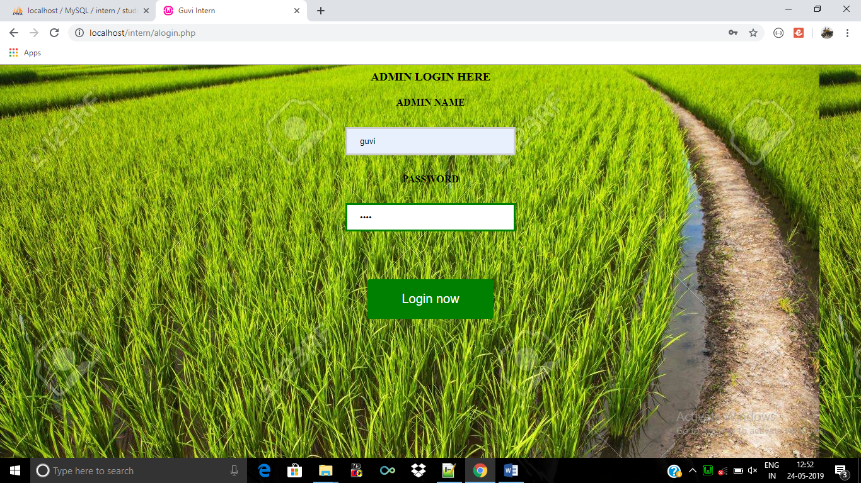

4.After Login, This page appears in which admin view the registered Details and Users Request with LOGOUT.

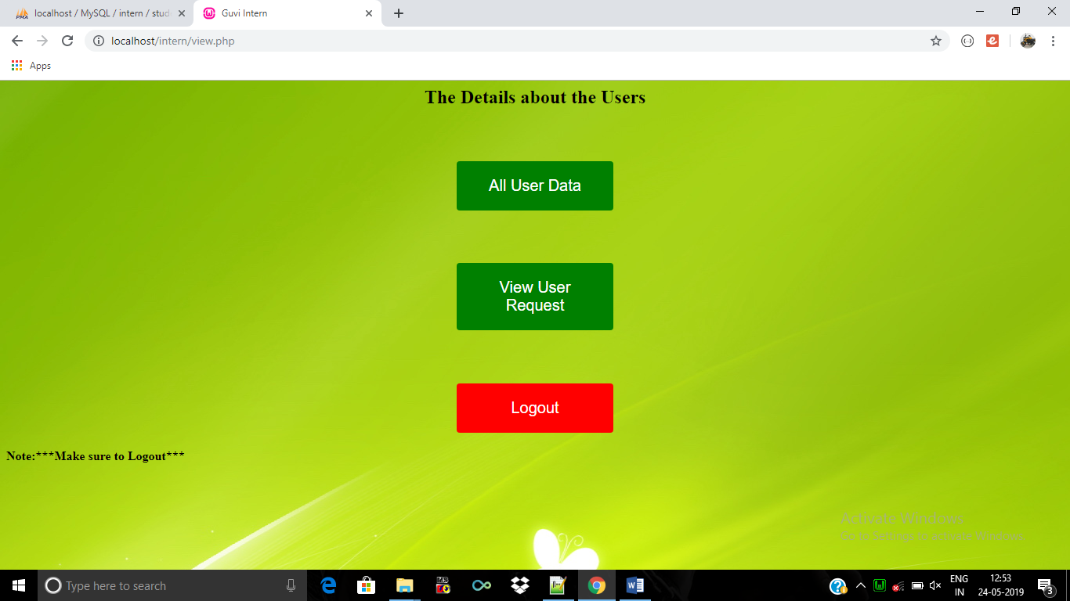

5.If Admin Clicked ALL USER DATA BUTTON (CONTAINS DATA RETRIEVED FROM BOTH JSON AND PHP )

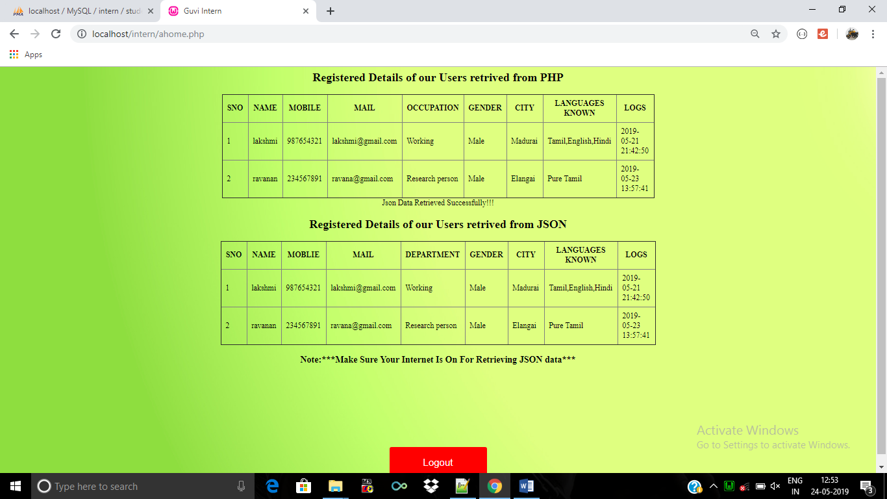

6.If the admin clicked VIEW USER REQUEST (I linked two tables and display data of user)

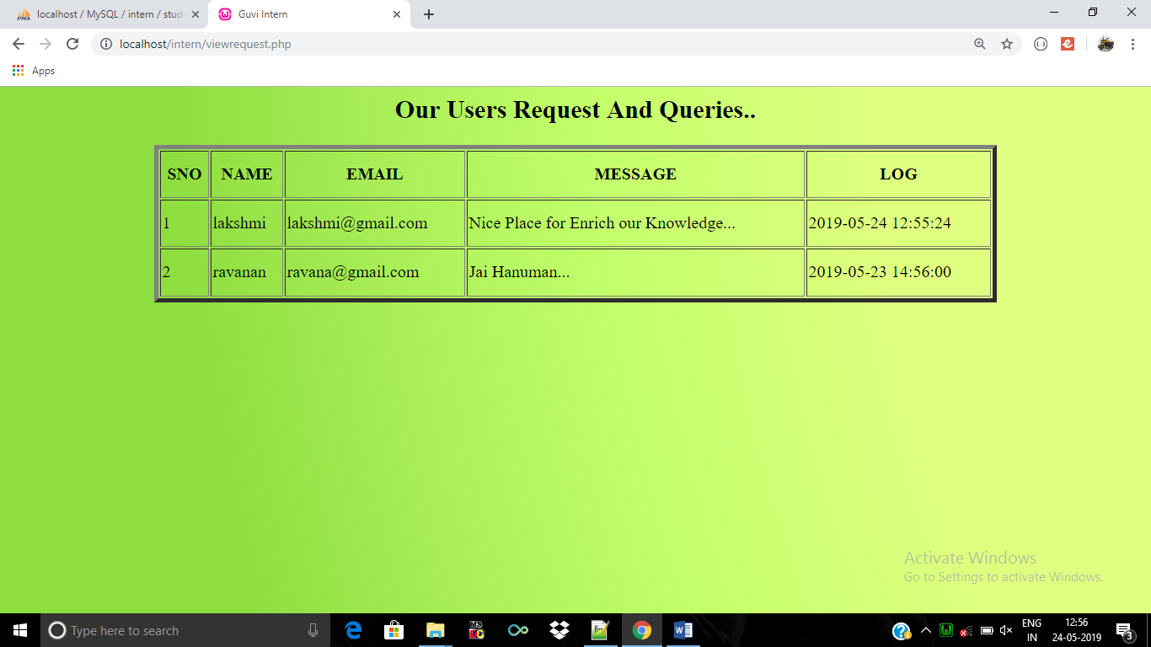

7.User registration Page with 7 Details

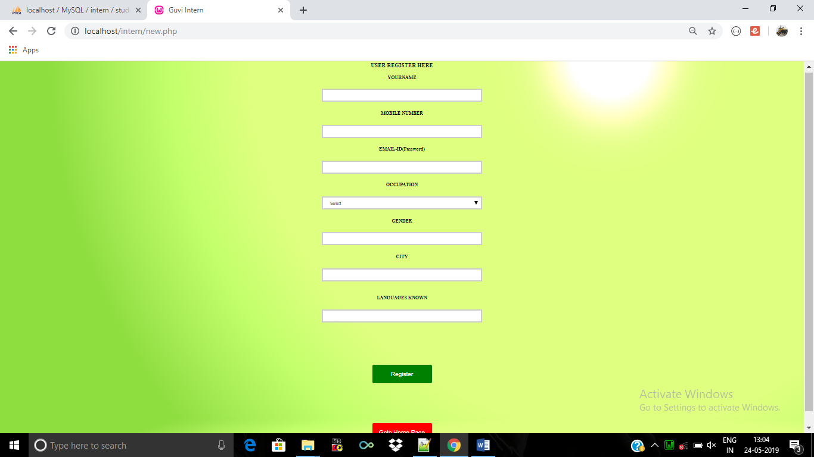

8.USER LOGIN PAGE: Login with registered email

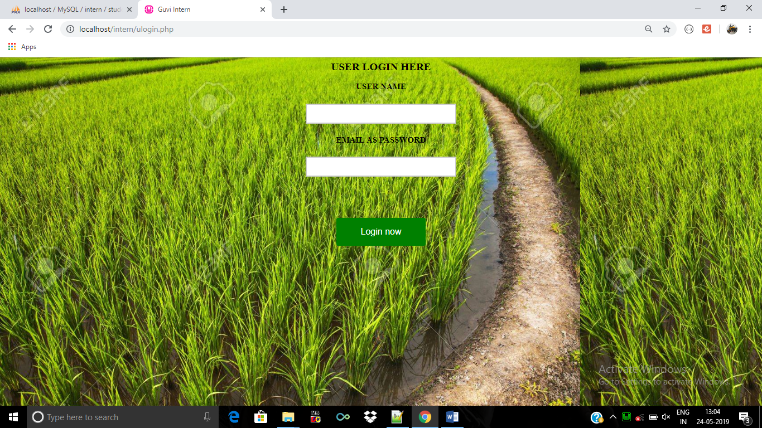

9.User Entered the Data to Login

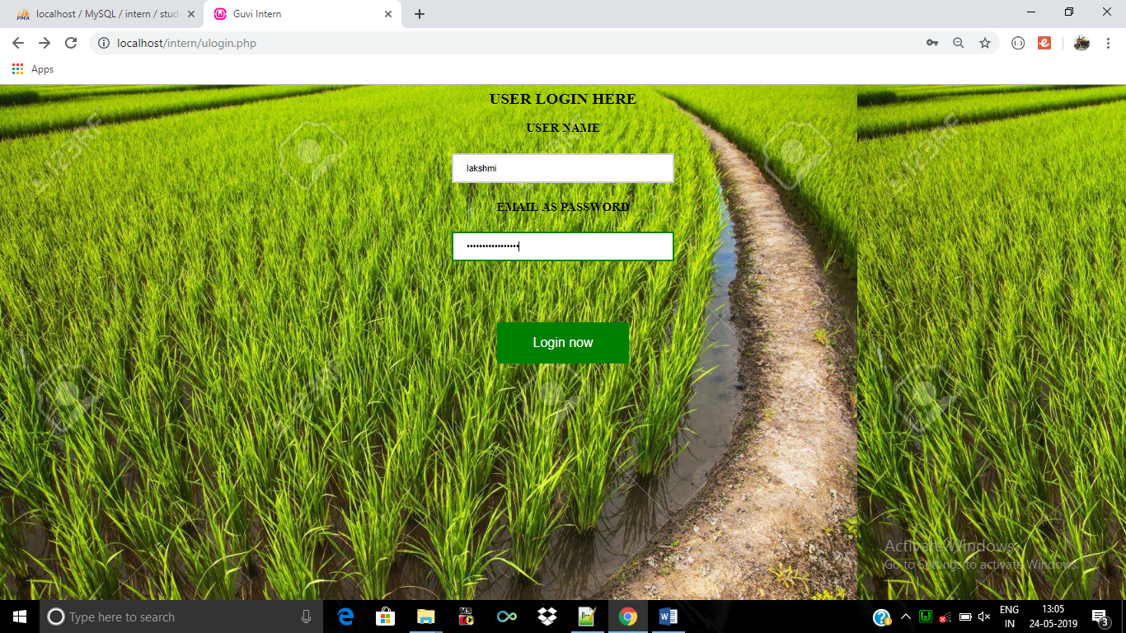

10.User Can entered Queries or comments and This can be viewed by ADMIN only (Latest Comment First DISPLAYED)

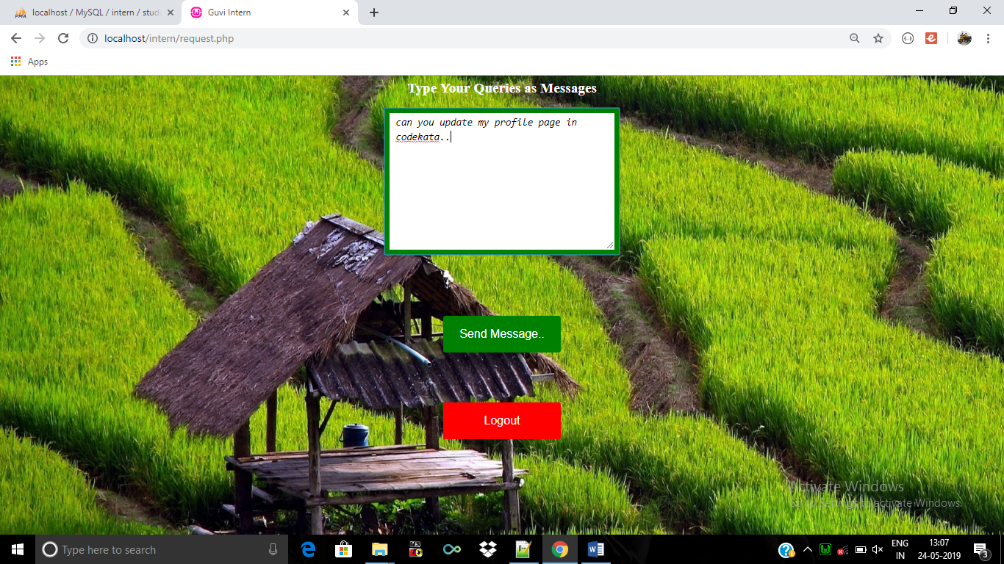

11.Simply Page for Me using CSS properties

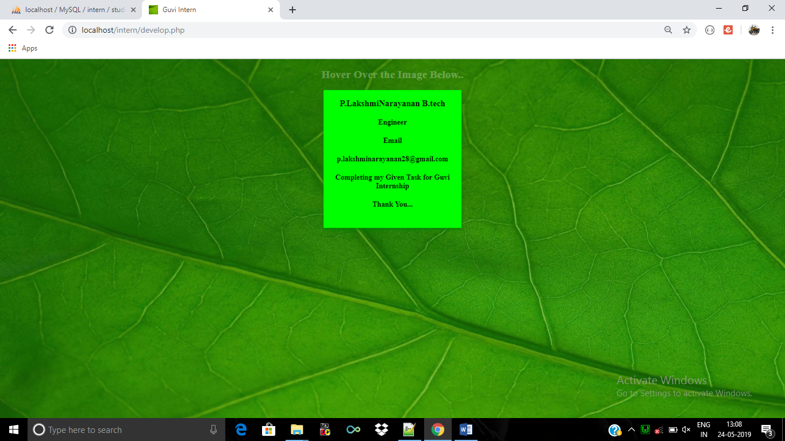

12.JSon Data retrieved:

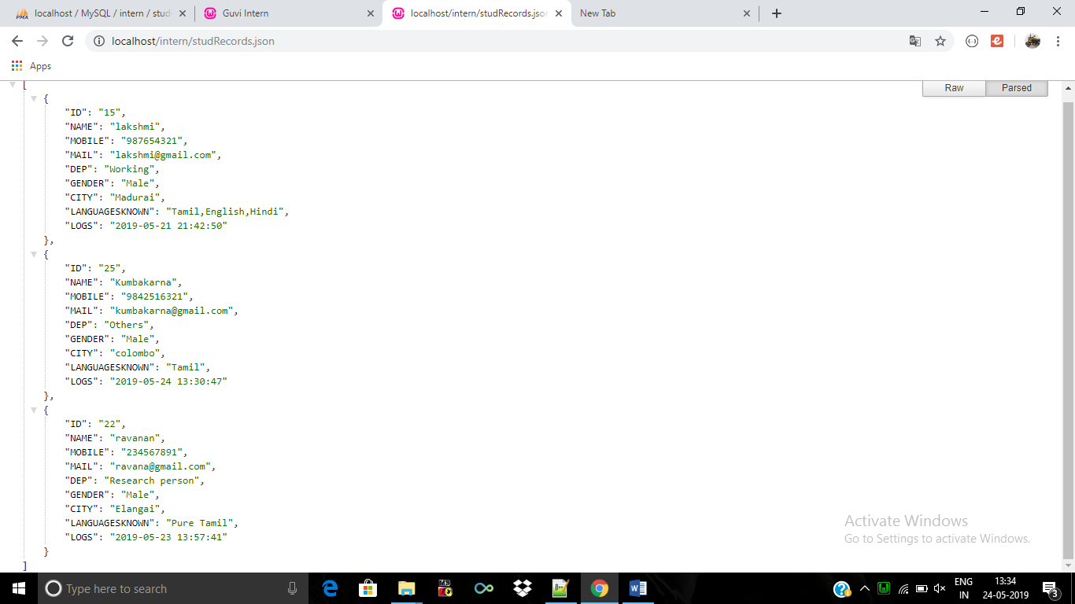

13.PHP Data Retrieved

